EXERCICES UNIT_LINUX_1

1. Choose one option in each question:
1.1. GNU/Linux: C
1.2. Linux: A
1.3. GNU project: C
1.4. UNIX: B
1.5. Linux Tovards: A

2. What is the difference between open source and freeware?

Freeware is totally free software while some open source software may be paid, but a few years ago they were considered the same.

3. Investigate about General Public License, Apache License and BSD License and explain
the differences in forum.

GPL – is a set of free software license terms that allow the software developer or end users to access the code and execute, modify, study, share. It was written by Richard Stallman with the Free Software Foundation. In the GPL they are all a series of copyleft licenses, that is, they must be distributed under the same or equivalent license terms.

Apache License – They use licenses to distribute software and documentation, accepting regular payments from users or corporations, and accepting grants for software products on the market. But ASF has a purpose and that is that all the software that is there is under the right to develop its own work and continue to distribute that software within Apache.

BSD License – It is like the GPL but imposes less restrictive rules on the use and distribution of the software.

4. Install Ubuntu-Mate in a virtual Machine with the following characteristics:

- Investigate the necessary Ram size
- Hard disk with 2 hard-disk: sda 15 GB and sdb 5 GB
- Partitions:
- Sda / with 7 GB
- Swapping with hibernation
- /home the rest of the hard disks.
- /var in sdb, size: 3 GB
- The user's login, which will be installed the operating system, will be 3 letters of
your first name, 3 letters of your surname and password: P@ssw0rd.

Take screenshots of the steps that you consider most important.

RAM size: Se requiere minimo 2GB.

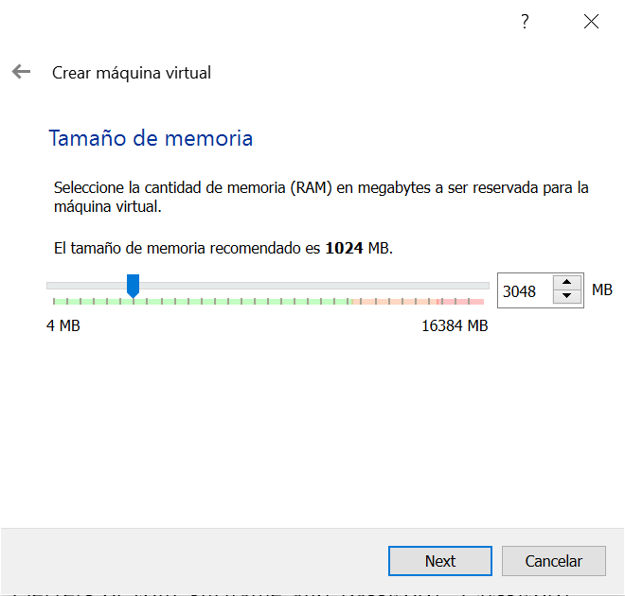

We assign the memory to our VM and continue with the installation until we reach the window where it asks us for the type of installation, here we will give More Options to be able to partition our hard disks.

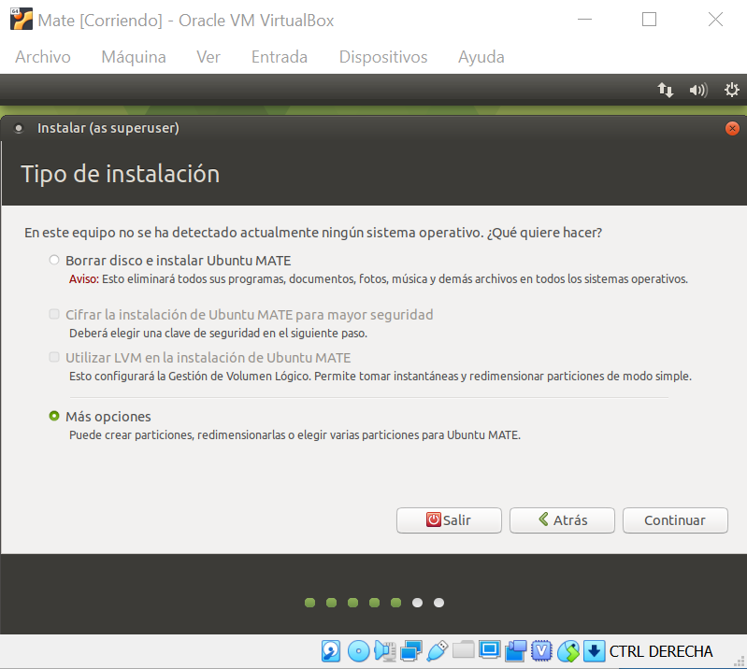

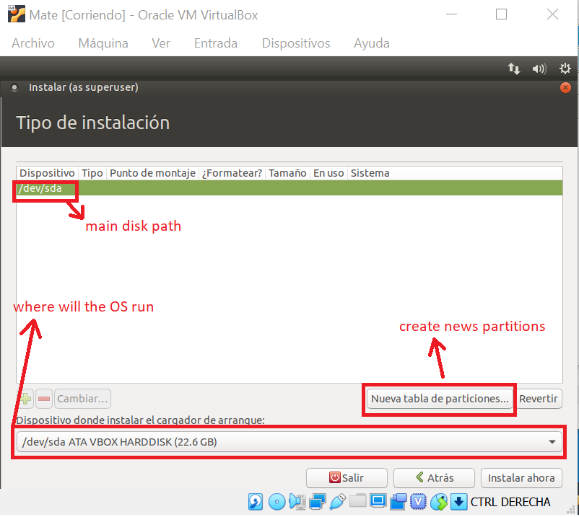

Here we see the hard disks we have, a sda and a sdb.

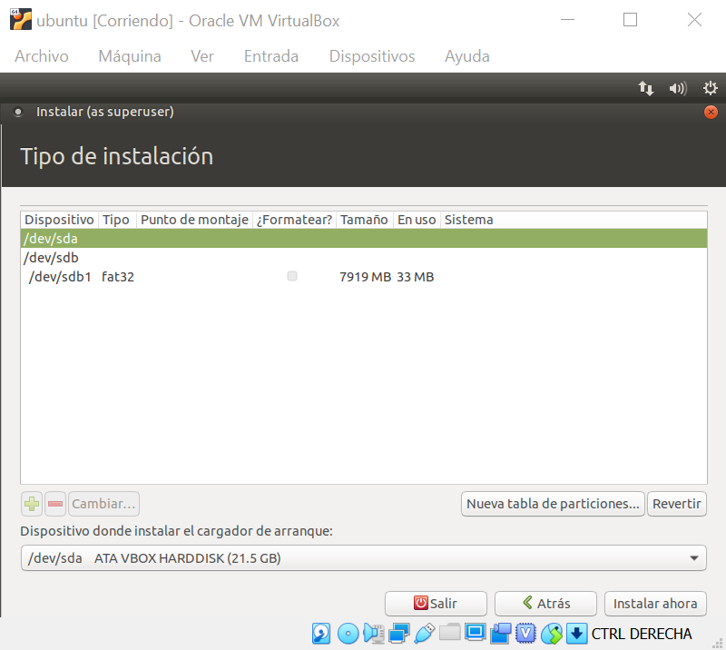

Now we are going to partition them. Click on create a new partitions and assign to sda the space created in the root / of ubuntu, the swap, / home and in sdb the same and assign / var of 3 gb.

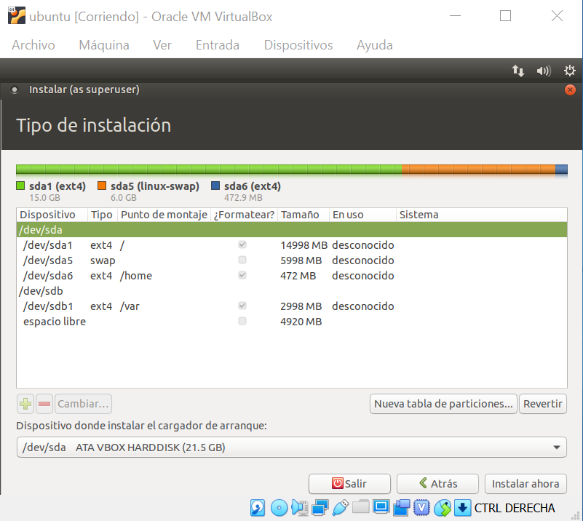

Once all the partitions are in, we will have to create the user and install.

Nota* no he podido asignar el espacio que se requería en el ejercicio porque no tenia suficiente espacio libre.

5. Once the last virtual machine is installed:

install the VLC media player with commands.

We have to do a: sudo apt-get install vlc in the terminal.

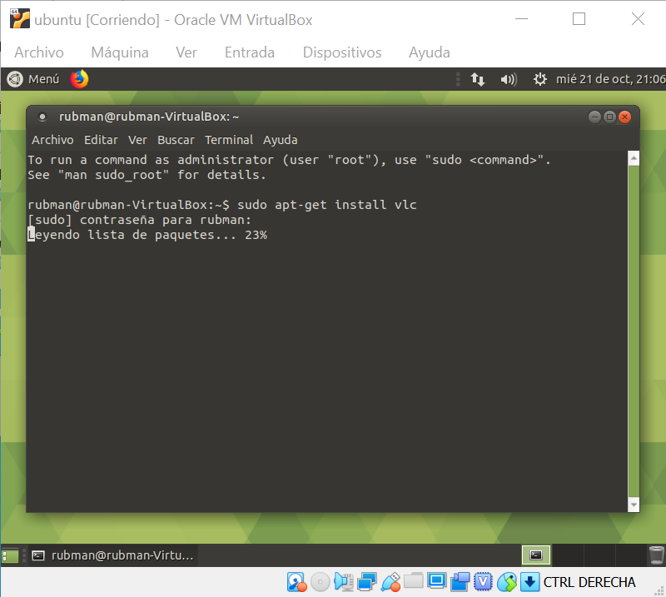

install Chrome using synaptic

Find our synaptic, google and install it.

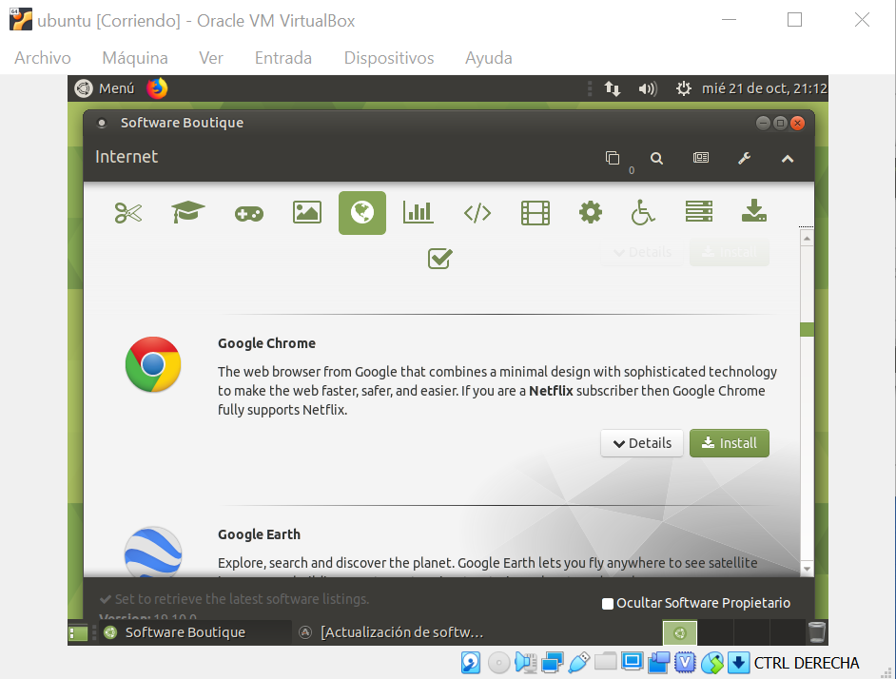

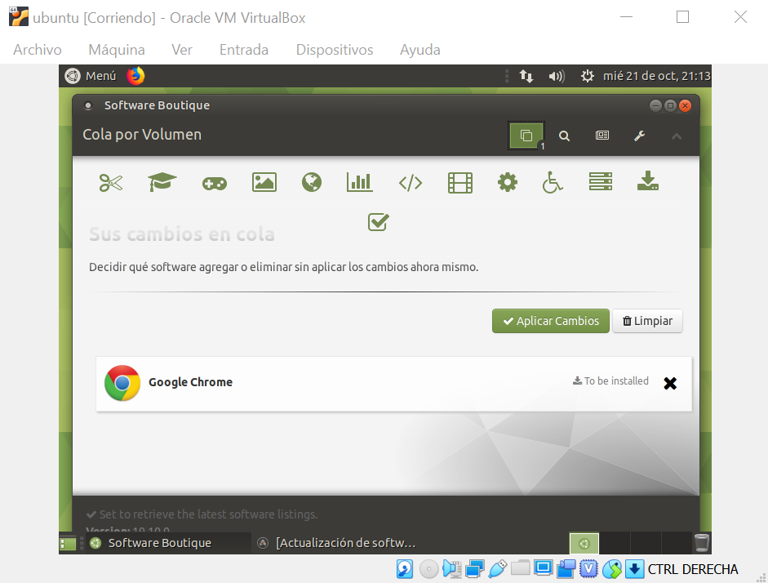

install using the package: audacity or gimp

We download this file from the web, then run it as an installation package and install.

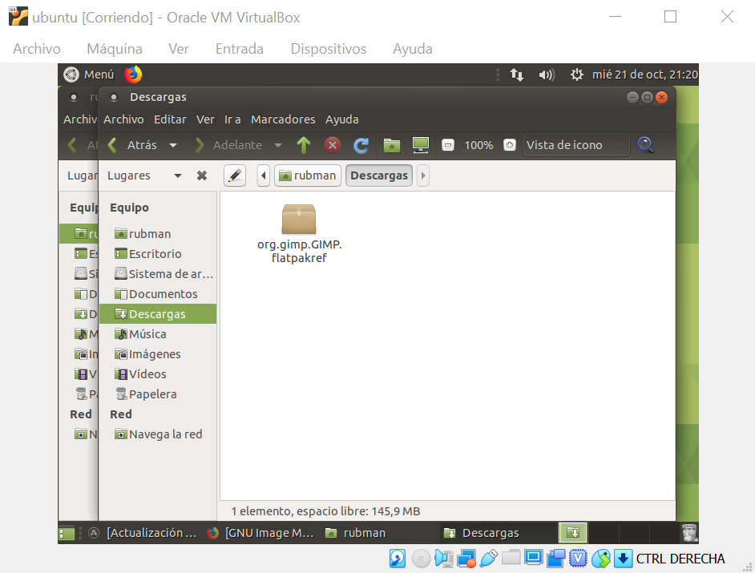

6. In a hard-disk, 6 partitions are needed in order to install Linux:

/
/home
swap
/tmp
/etc
/var

Tell how you would make the partitions, bearing in mind the kinds of partitions that we can use.

